**A:01 Database Design and SQL**

1. Put the data in RDBMS format style with lower case table named “student” and column names with words separated by underscores.
2. Label the two primary keys that make up the concatenated, or composite key.

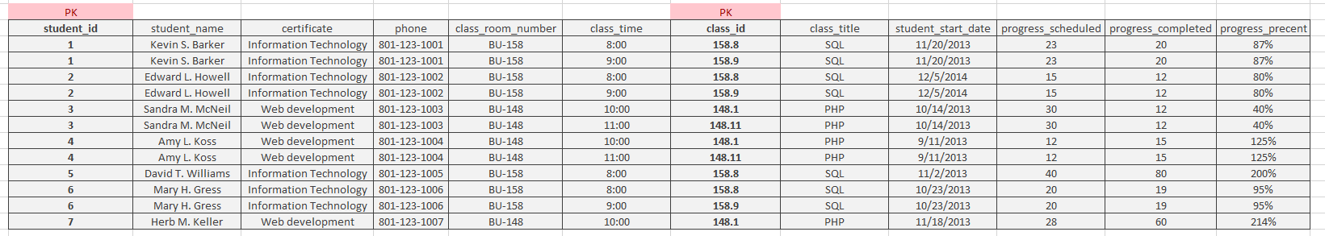

1. Determine if columns may exist without one or the other part of the concatenated keys (partial dependencies).
2. Discard “progress_percentage” as a derived column of progress_completed divided by progress_scheduled.
3. Create another table as several of the columns depend on only one part of our concatenated key.

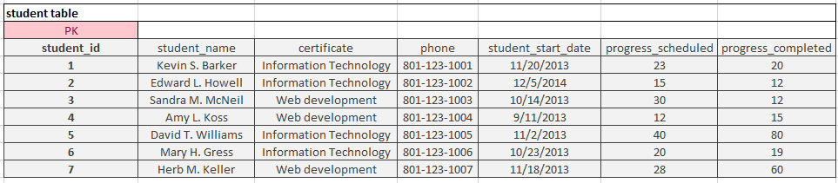

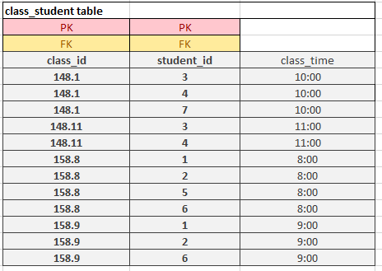

1. And create an intersection table to resolve the many to many relationships of students to classes and classes to students.

